**Demand and Capacity Team UEC A&E Department Model**

|  |  |
| --- | --- |
| Author | Paul Bullard |
| Model Version | Alpha v1.5.3 |
| Date | 13/08/2019 |

Contents

Step by Step User Guide 2

Development Information 12

# Step by Step User Guide

The following guide applies to the model version listed in the table above. Processes are subject to change as the model develops, and are limited in some instances by outstanding work to be done. Please see the development information at the end of this document for additional features that will be available in upcoming versions of the model.

Model builds prior to release will generally be unlocked, and key cells will be modifiable. If errors occur after inadvertently changing cell values or formulas, it is recommended that the model is closed and re-opened.

**Notes**

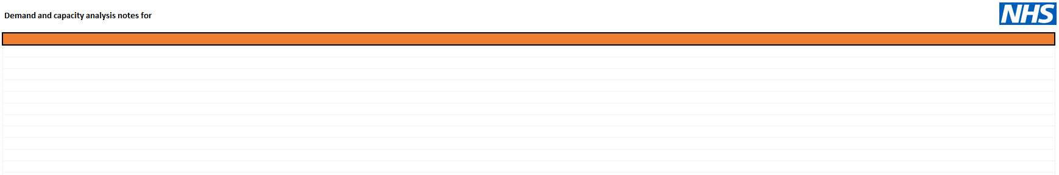

This sheet is a simple text entry for any notes that need to accompany the model.

**Setup**

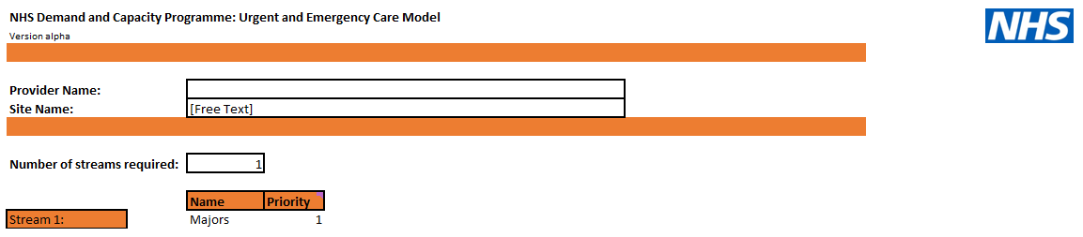

The setup sheet is used to determine the layout of later sheets in the model. A Provider and Site Name should be entered. The number of streams required dictates the number of streams/groups that the department uses.

Each stream should be named and given a treatment priority. The treatment priority is used to assign capacity to the highest priority patients if the capacity is able to ‘flex’ between patients in different streams.

**Note: details on how to stream/stratify patients entering the department will vary by organisation, but some methods will be collected and shared by the team at a later date.**

**Demand**

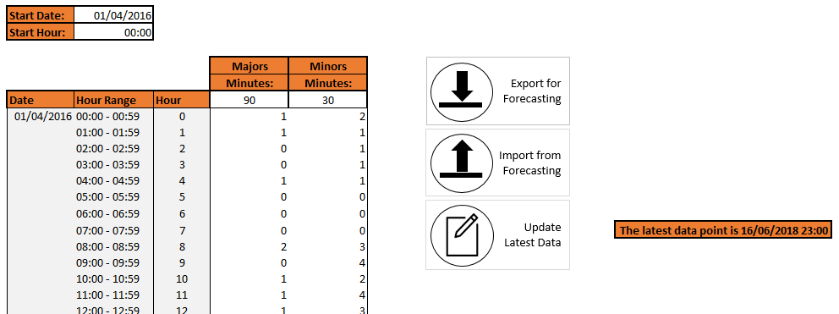

The demand tab is used to enter historic demand information per hour, per stream. Up to three years of information can be entered in to the model.

The initial start date and start hour should be entered by the user at the top of the sheet. This will auto-populate the date, hour range and hour columns in the model.

If you are updating the model to include more recent data, clicking the Update Latest Data button allows the user to enter up to four weeks of additional demand information that will added to the bottom of the demand table in the tab, ready to be exported.

Once arrival information has been entered per hour per stream, the Export for Forecasting function can then be used to extract the data back out in a format that can be processed by the forecasting app.

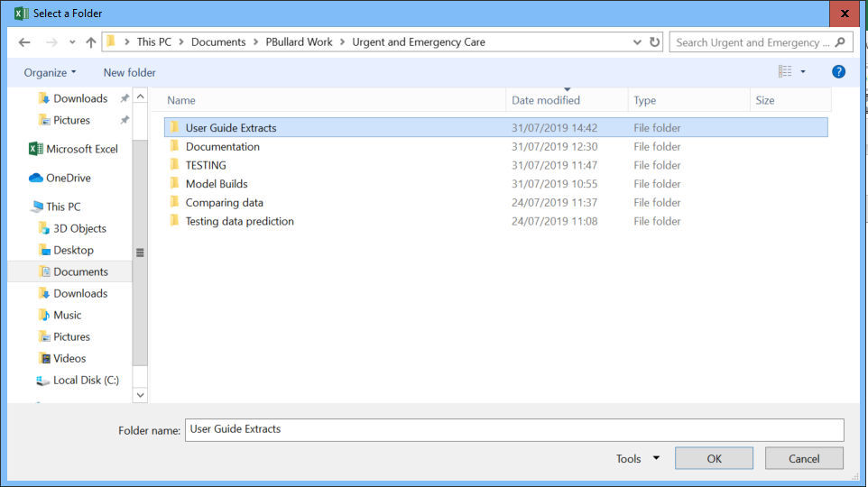

The model will ask the user to select a folder to save the exported files to. Clicking OK will then start the export process.

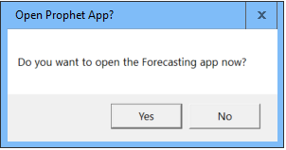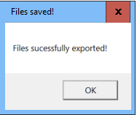

The model will display a message if the export has been successful, and will prompt the user to open the forecasting app.

**Note: the app is currently hosted at** [**https://paulgbullard.shinyapps.io/EDForecasting/**](https://paulgbullard.shinyapps.io/EDForecasting/) **, if the user declines opening the app at the prompt. Please note that this address will be updated with the full release of the model.**

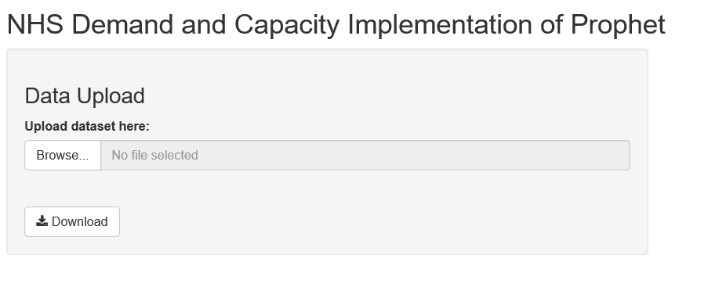

The forecasting app will open. The user should use the Browse… button to navigate to where the files were exported from the model. On selecting the files, the app will start to process the data.

**Note: Once the file has been uploaded, there will be loading bars displayed on the right hand side of the page. Please wait whilst the app processes the file, and do not click on the download button until a graph is shown (this indicates that the data has been fully processed).**

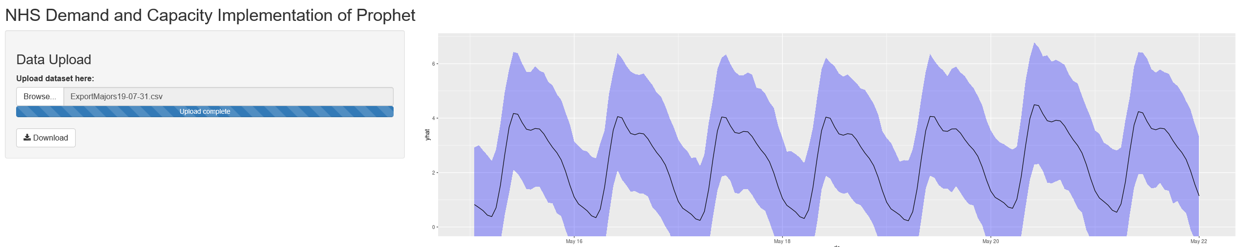

Once the file has been processed, the data report can be downloaded from the app and imported back in to the model using the import from forecast button on the Demand worksheet. Select the location of the downloaded file.

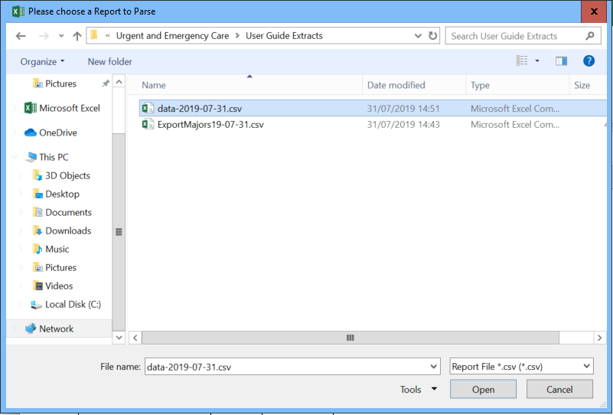

Once the file has been successfully imported, the Demand Analysis worksheet will open, presenting the expected arrivals per hour for the next week, with 95% confidence bounds.

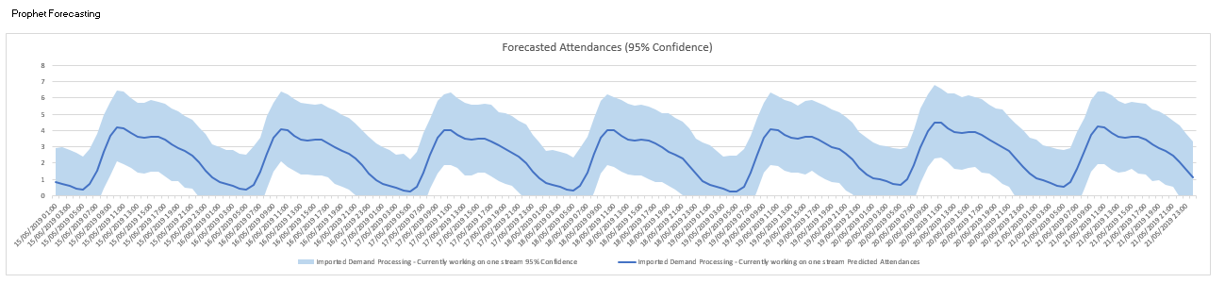

**Capacity – Shift Config**

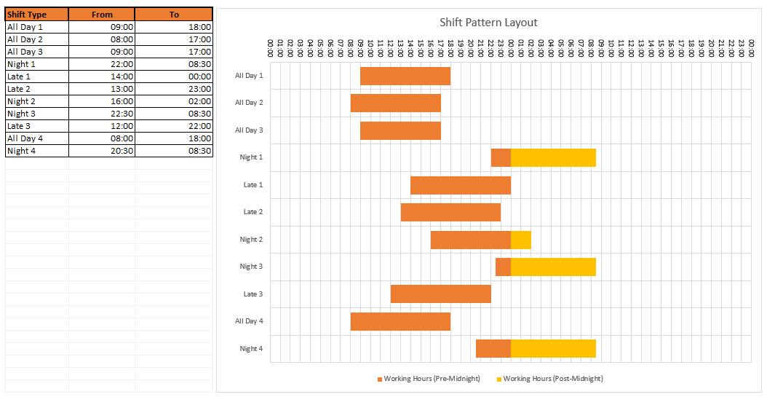

The capacity – shift config worksheet is used to express the different types of shifts that resources within the department can be expected to work. Each shift type should be given a name and a start and end time.

**Capacity – Role Config**

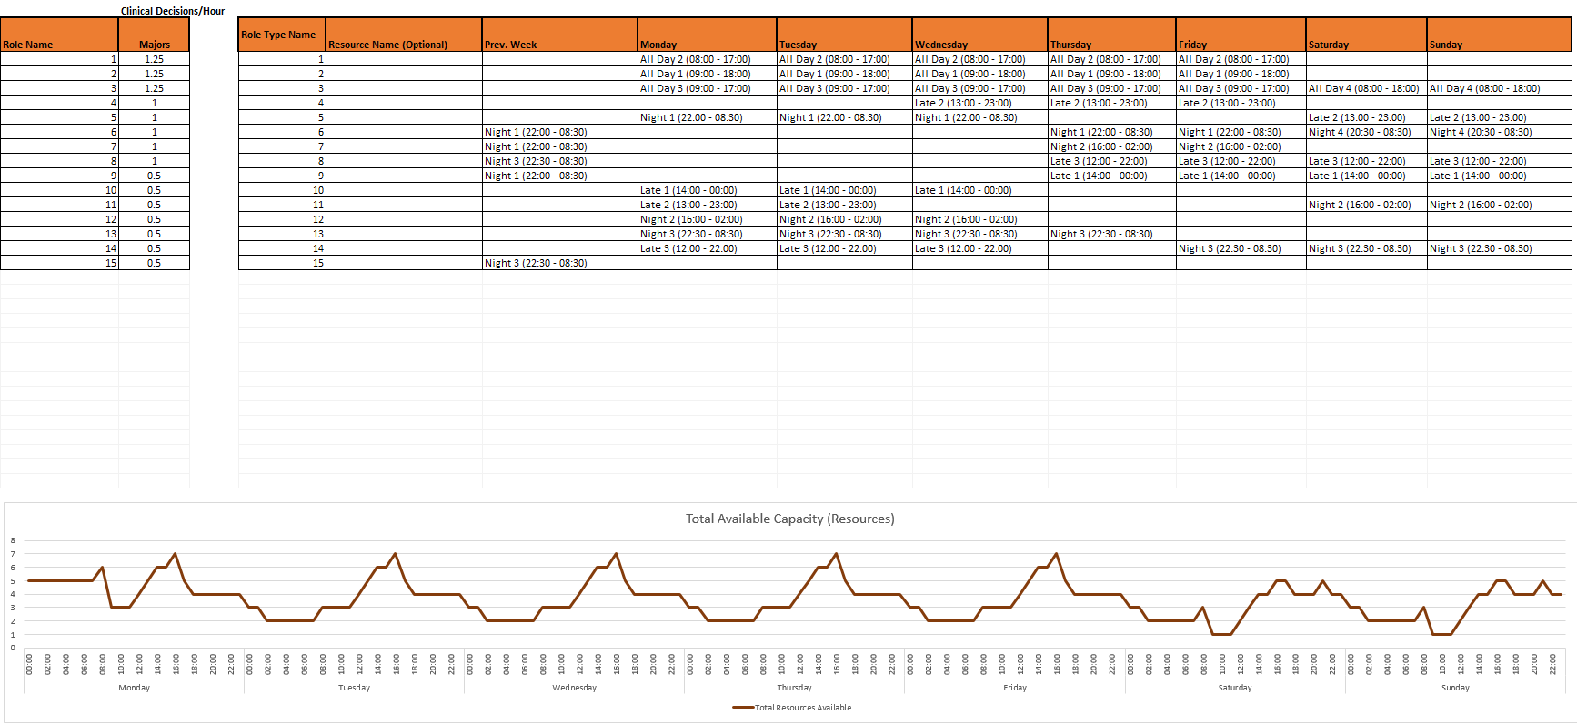

This sheet is used to define the different types of role within the department, there ‘productivity’ in terms of clinical decisions per hour, and the planned shifts that they are going to work over the next week. Each role may encompass multiple staff operating at the same productivity but on different shifts, and therefore each role can be selected multiple times in the rota table on the right.

The summary table at the bottom of the sheet visualises the total available resources in terms of people (i.e. how many roles) are available per hour per day. It is important to note that this is not the available capacity, as this needs to be transformed to the same CDMH unit that the demand is multiplied by.

**Capacity – CDMH**

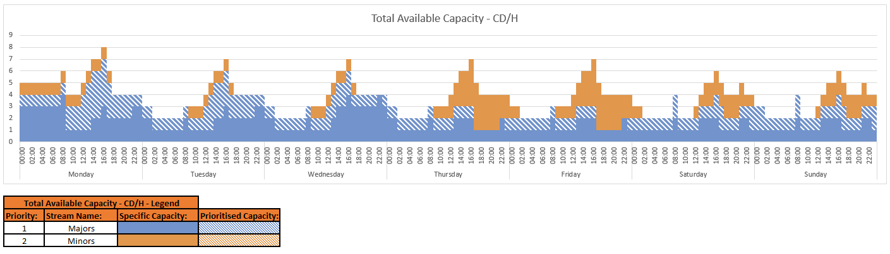

The Capacity – CDMH sheet is a summary sheet that displays the available capacity in terms of total decisions that could be made per hour per day.

The capacity is shown as a number of stacked bars, in the priority order set in the Setup tab. Solid bars indicate that the capacity is specific to an individual stream, and hashed bars indicate that the capacity is shared between two or more streams – the colour of the hashing indicates which stream is the priority.

**Parameters**

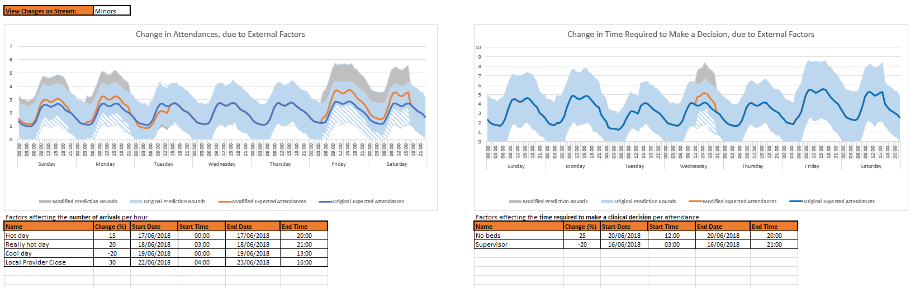

The Parameters tab is used to increase or decrease key model outputs based on external factors that have not been accounted for in the model.

The user can use the options to account for external factors that affect attendances (a hot day, for example), and external factors that influence the time required for a decision to be made (a lack of pathology availability, for example).

Changes are measured as a percentage and can be positive or negative.

**Note: there will be the option to account for external factors that affect the availability of capacity in an upcoming version.**

**Summary**

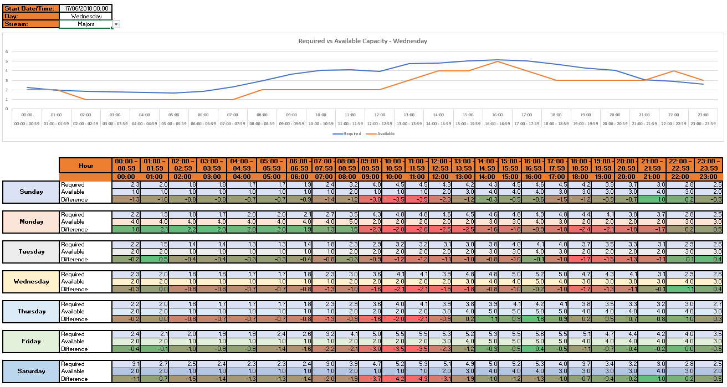

The summary sheet shows some of the key outputs of the model.

The table shows the difference between the predicted required capacity and the available capacity. A positive number indicates a surplus of capacity, and a negative number indicates a deficit in capacity.

**Note: there is further work to be done on the Summary tab around the impact of backlogs building throughout the day. Please see the development information for further information.**

# Development Information

**Notes**

Information

Basic entry sheet that can be used to record any notes and assumptions made as the model is completed.

Outstanding Work

N/A

**Setup**

Information

Entry sheet for setting up the layout of the model. Number of streams required are set here, as well as the names of the streams and their priority (used when assigning available capacity).

The purpose of the priority selection is to accurately reflect the available capacity for each of the streams if resources can be used between multiple streams of patients. The initial build assigns capacity to the highest level of priority first.

Outstanding Work

Streams should not share a priority – this currently works if the user goes from the first stream down, however further development needs to be done to ensure that the same priority is not given to multiple streams.

**Demand**

Information

Entry sheet for demand information. Start date and start hour is defined by the user. Demand information for three years can then be entered in to the grid. It is important that the minutes per decision per stream information is entered.

There are two buttons on the Demand worksheet that assist with the forecasting aspect of the model – Export for Forecasting and Import from Forecasting, both of which are used to interact with the forecasting web app.

There is a third button, Update Latest Data, that is designed to assist the user with entering more recent data (for up to four weeks).

Outstanding Work

Awaiting further development feedback.

**Demand Data Update**

Information

This sheet becomes available when the user clicks the Update Latest Data button. It allows the user to enter four weeks worth of demand data, that will be added on to the end of the Demand table. As the datasets used within the model are large, it is designed to stop the user having to scroll a long way down the Demand sheet to enter new data.

The user must start to enter data at the end of the period already in the Demand tab, and they cannot change the stream or CDMH values. Clicking Save Latest Data will move the data, and Return without saving will re-hide the tab without copying any data across.

Outstanding Work

Awaiting further development feedback.

**Demand Analysis**

Information

This sheet displays the outputs of the forecasting methods – a basic version based on using Excel to predict attendances based on last week, and the outputs from the Prophet forecasting model.

Outstanding Work

Some of the options on the sheet reset the colours of the graphs – this needs to be reviewed.

Question around how to present the alternative forecasting methods in a logical way.

**Capacity – Shift Config**

Information

Entry sheet for configuring the different shift types used by the department. Here, the user dictates the start and end times of shifts that are assigned to resources within the service.

Outstanding Work

No current outstanding work – receiving feedback on layout and usability.

**Capacity – Role Config**

Information

Entry sheet for configuring roles in terms of ‘productivity’ and shift layout. This will display the total available capacity in terms of **resources** (i.e. clinical decision makers on shift at any given time), but is **not** the available capacity in CDMH.

Outstanding Work

A fuller explanation of “Roles” needs to be devised, that works in operational language.

**Capacity – CDMH**

Information

This sheet is used to show the conversion from resources to Clinical Decisions. Depending on the selection made, the user can view the available capacity for each stream.

Capacity is split in to each stream, but can also be considered ‘specific capacity’ or ‘prioritised capacity’. Specific capacity is capacity where the role only has productivity entered against one stream. Prioritised capacity is capacity where the role has productivity entered against multiple streams – the capacity is considered part of the highest priority stream, but with an understanding that this capacity may ‘flex’ to lower priority streams if required.

Outstanding Work

Prioritisation may be better accomplished through recommended practice when setting up roles – this is to be covered in the wider document to be produced.

**Parameters**

Information

The Parameters sheet is used to modify the required capacity by accounting for potential external factors. This initially includes external factors that influence attendances (a hot day, for example), and external factors that influence the time required for a decision to be made (a lack of pathology availability, for example).

Changes are measured as a percentage and can be positive or negative.

Outstanding Work

Currently the dates for the periods selected do not update when new demand data is entered in to the model.

There needs to be the option to change the available capacity based on external factors, such as expected staff sickness or known staff absence. This should work in a similar way to attendances.

**Summary**

Information

This sheet is used to show the final comparison of Required Capacity and Available Capacity, both graphically and in a tabular format.

Outstanding Work

The sheet is currently static to the data imported from the Prophet forecasting app, and needs to be adaptable based on which method has been used.

The chart currently shows the exact predicted value for attendances on any given hour. Some further development around where to set the required capacity level needs to be completed (i.e. 80 to 95th percentile).

There are plans to introduce a ‘backlog’ function to the summary chart to measure the impact of delays in decisions, and the knock on impact that this has to the required capacity later in the day.